NHB+ The Hidden Architecture of Quiz Funnels

How to Copy Chief Copy or Coffee Chief Your Own Copy

The brain has to delete, distort and generalize -> to accept, store, manage and make sense of data and reality.

Maximize, Minimize and Simplify

The brain doesn’t want to expand energy. If it has to think, you think for it. If it has to imagine, you help it imagine. If it has to come to a conclusion, you help it come to a conclusion, etc…

Maximize

- Outcomes
- Results
- Retainability
- How easy it is
- Time to results (less)
- Proof
- Evidence
- Who it works for
- Believability

Minimize

- How long it takes
- How hard it is
- Doing math
- Finding proof
- Finding evidence
- Validating evidence
- Hyperbole when appreciated. Only liars talk in exaggerated statements

Simplify

- The process
- How easy it is
- How “all you have to do is”

Within boundaries

- Is it realistic
- Is it believable
- Is it relatable
- Is it attainable

Mindset: The Fearless Exercise

Fear is the mind looking into a void in the future.

You can not be afraid of the past.

It’s also “in the present”.

The human brain looks at timeline as a mental construct.

- You can’t go to or change the past.
- You can’t go to the future and change it.
- We’re left with “the present”
  - But if you zoom in, to the hour hand, the minute is ticking.
  - If you zoom on the minute hand, the second are ticking.
  - If you zoom in on the seconds, the milliseconds are ticking.

What are we afraid of in the future? We are afraid of loss.

To become fearless. You have to become lossless.

You say “where is this fear coming from?” All fear is in the future.

What am I losing here? (answer comes)

What am I going to gain out of this loss?

You can not lose something without gaining something. The brain, the universe, etc…will always fill the void.

Fear manifestation:

- Resistance
- Concern
- Worry
- Stress
- Fear
- Anger

All products are rooted in: survival, reproduction, safety/security and status and time.

“I am a creative”

I am creative = I am not anything else.

The subconscious mind works on deleting 1st, distorting and generalizing.

When you say I am. You ask the subconscious mind to DELETE ANYTHING ELSE YOU COULD BE. WHICH MAKES IT VERY DIFFICULT TO ACCEPT.

Loss and gain ratio?

I am 1 thing = I am not infinite things.

You alway say what you are and what you are not at the same time.

I am that I am = because he/she believes that he is and he is not at the same time.

“I am this means I am not that”
Whenever I say, I am white, then I am not black, asian, latin, that means I would be in conflict with those that are opposite of me.
The I am statement by adding anything to it creates automatic exclusion and conflict.
If you say I am = that is one thing, but because the way the mind works means that you are not all those other things, and there are far more things that you are not, than you are, which means in numbers, you automatically admit that you are not infinite positions and that is how you become VERY VERY VERY VERY VERY VERY VERY VERY VERY VERY VERY VERY VERY VERY small.

When someone goes “You’re really good at X” = I am great X = I’m not great at other things.

I have creative abilities. Not that I am creative.

I am creative = I am not anything else = than who am I? I am nothing.

Have you ever noticed people who are very successful, they all have a thing in common: “I’m a father, I’m a businessman, I’m a philanthropist, I’m a runner, etc…”

“I am a copywriter”

- I am not an offer owner
- I am not a business owner
- I write for others
- I rely on others to pay me
- I depend on others for my livelihood
- I have to get and keep clients
- I have to constantly write performance copy
- Etc…

“I am a rapper”

- I am not a business man
- I am not a brand
- Etc…

You have to get out of this limitation to transcend who you are and grow.

Fear identity - “I am creative -> I am nothing else. This nothing else creates the fear, because it's the loss of everything else.

—----

The Hidden Architecture
of Quiz Funnels

Quiz funnels work extremely well on generalized targeting because they are the ad, the targeting and the intent mechanism all in one.

Most quiz models identify the problems, this model creates them.

You always want to be in control of the sales process.

Most people ask questions that identify the person, but not questions that change the person.

A good quiz funnel changes the person while asking them questions.

When you ask identification questions, people become very very very defensive because they sense you want something from them.

- I built a lot of quiz offers
- And #1 thing I see is that just about everyone is getting quiz offers wrong
- The future of offers is all about personalization.
  - Every market evolves to personalization.
  - The biz op space went from books, to courses, to coaching.
  - What is coaching? A form of personalization.
  - When it comes down to many products that are all competing to fulfill the same service, those that can personalize win.
  - Generally speaking, personalization is typically reserved for people with money.
- Why personalization?
  - Because that is the highest form of inclusion.
  - Let's say we have 1 million people.
    - If our offer only works for say 1%, we can only sell to 10,000 people.
    - Why? Because of measures = human beings have measures = which are limitations.
    - This is why we have to work on inclusion
    - The problem without personalization, inclusion for mass markets becomes very difficult.
  - Quiz funnels fix this problem of exclusion because they can absorb everyone.
  - The problem is if they do absorb everyone, they get a mixed bag of customers.
  - It’s hard to sell them because they’re all different.
  - So the quiz must change them so they are all the same, so our sales messages work on them.
- So the nature of the quiz offer is basically to inject “personalization” into the offer
  - Make it about them
- Who’s the #1 trust? Ourselves, #2 those that are just like us (this is why rapport is so key), #3 those that understand us (this is why personalization is so important).
  - If you think about it…just about any service has a bit of personalization to it.
  - Doctors, interior designers, painters, weight loss, etc…
  - The quiz makes it so that we understand them.
- Software companies have variable pricing.
  - Why is the American government the richest government in the world?
  - They have a variable tax rate. Get something from everyone.
- Now you can take the market from 10,000 people to about 300,000 people out of the 1m. So you 30x your market reach.
  - What happens when you 30x your market research? You get a whole lot more people to respond on ads, offers, everything.
- One of the ways you can impose “measures” on a market is by saying that it only works if it’s personalized.
- The brain has a thing where it can’t have a void. The quiz creates and fills the void at the same time.
- Typically quiz models tend to work in very mature markets where “nothing worked” and they give “hope” via personalization.
  - This is why they’re big in weight loss, astrology, insurance, etc…
- Coaching in itself is a form of “personalization”
  - However the way coaching is sold is not very personalized. That’s the flaw.
  - There is a form of coaching sales that is personalized and that is high ticket phone sales.
  - This is why a lot of these guys want quality leads.
- All markets converge to “lead gen” once economics are figured out, and then the product becomes “personalized” due to the need for INCLUSION
  - If there are 100 people competing for a customer on straight sale
  - Those that optimize for LEADS basically optimize upstream, they catch fish before other fisherman can fish
  - Lead gen = free
    - Anything free is inclusion based
  - Straight sale = cost
    - Anything that has a cost is exclusion based
  - Hard to compete with FREE, because there are no trade offs
  - This has massive inclusion because anyone can afford “free”, we have removed limitation.
    - So in order to increase inclusion, you must remove limitations or measures.
      - You don’t have to have $100 to get access to this.
- Then once you optimize for lead gen, you optimize for time, meaning cash conversion cycles.
- The best way to optimize for a cash conversion cycle is to once again focus on INCLUSION
  - “How much is the price? “Depends on how much money you got?”
  - What personalization does it allows us to go down these paths of pricing
  - Then the reason we can offer variable pricing is due to personalization.
    - As “everyone is different”, “everyone pays a different price”.
  - You’e also personalizing levels of risk
    - Every product has a risk, so this becomes the biggest factor
- This is true because of astrology & porn
  - Their economic models are one of personalization
- What do we need to do to make the quiz efficient?
- This is true because of astrology & porn
  - Their economic models are one of personalization
- What do we need to do to make the quiz efficient?
- The above is the economic structure, below is going to be the psychological structure.
- A quiz offers an outcome, a pay off, something that allows them to change their situation.
  - Discover what’s holding you back from losing weight
    - They assume a problem that the person wants to lose weight
  - Discover 3 foods that help burn belly fat
    - They assume a problem that the person wants to lose belly fat
  - From where they are, to they where they want to be
  - It changes their situation from “bad” to “good”
  - It’s therapeutic in nature
- Most people going through this process will have some type of negative emotion starting out, otherwise why would they want to change it? Who changes a positive emotion? No one.
  - If I’m happy, the only way I would want to change is if I think something would make me happier.
- What most quiz funnels do is they just ask random questions and the smarter ones will ask “financial qualifiers” aka “how much money you got?”
  - Most sales bros are asking for financial questions as the primary because of “unqualified leads”
  - A lead is not qualified because of their financial situation, but rather their emotional situation.
- You can generate intent and you can generate inclusion.
- The formula for intent is as follows:
  - Anytime you have curiosity but no intent.
    - If you intend to buy it, you intend to use it. And you can’t use it unless you imagine yourself using it.
    - They can not see themselves using the product or getting the outcome.
    - So they are merely curious about it, to see how it would feel to possess it but something is preventing them from possessing it.
    - Negative possession
  - Interest is what happens before intent.
  - So interest -> intent
  - Intent is built on what happens FOR THEM without expansion of energy.
    - So if they have to expand their energy, then the mind will not go there.
  - That is the formula for intent.
- Lottery is people seeking to become millionaires without energy expansion.
- I see a lot of people doing quiz funnels, talking about quiz funnels, running quiz funnels, but I don’t see anyone doing quiz funnels right.
- Most people make the quiz offer with random questions that have no purpose other than how much money you got?
- Every single word, action, move, element on the page has to have a purpose and its job is to affect the conversion via change work.
- Then the question becomes…what changes and how?
- If you don’t do this, then you’re leaving things to chance.
- All change comes with a question
  - When you get people to ask questions introspectively, that’s when real change begins, and when change begins, the BUYING PROCESS BEGINS.
- What’s the best place to put questions where you can do this? A quiz funnel.
- The real magic in a quiz funnels is how those questions cause them to accept new thoughts as reality as truth.
- If you think about the 3 step sales page
  - Agree to problem
  - Agree to solution
  - Agree to product
- Every question should be reflective into the problem state to make them think.
- You want to have this arc that goes undetected.
- What you’ll notice me doing a lot in copy is I’ll start with “I” and then i’ll subtly transition into “you” without YOU noticing it.
  - When I’m talking about “myself” = I’m not talking about YOU, and therefore you are not defensive.
- The start of the quiz should be inviting, the 1st 2 questions that are positive in nature and giving them something, the next (middle set) is neutral, and then go into negative.
- Questions that make you realize that you have a problem.
  - They imply that you did something wrong.
  - “Why did you cheat on me”
    - This assumes that you cheated.
- This takes the mind and takes it from feeling good, to feeling bad.
  - So what happens is they came in feeling bad, the quiz made them feel good.
  - Then the quiz hijacks the mind, thru questions into feeling bad.
- We feel bad when we question ourselves.
- Problem state in ad -> solution state on page -> positive, back to even more problematic.
- Identify them
- Identify the situation
- Identify the problem
- They have to agree to these things

Before they get to the quiz, the ad should entice them to discover their limitations that are preventing them from getting the outcome.

Then use the measures for bringing the limitation to light.

Because to go from where they are to where they want to be, there is a limitation in the middle, once they discover this limitation, that will allow them to move fwd.

Ads are them probing into their limitations.

Diagnostic marketing is the future.

Start - positive questions or identifiers. These are external questions.
- If you put identifiers 1st, the quiz take rate will be LOWER than if you put positive questions.
- “I tend to”
  - I tend to eat too much
  - I tend to whatever
- These are disassociated so they don’t feel much, cuz it’s not about them, it’s about the thing they do.
Middle - neutral questions

- It’s about what they do, where they’re at etc…

End - negative questions

You questions on the front
Back questions - I am questions
I am answers cause negative ownership

In order to help them get out of the problem they have, we have to make them aware and accept the problem.

If someone is a smoker, we have to get them to accept the fact that smoking is bad.

- “I have”
  - I have had this problem for 5 years, 10 years, 15 years, 20 years
- “I am”
  - I am a little bit ashamed of my weight
  - I am quite ashamed of my weight
  - Etc…
- “No matter what I do I can’t lose weight”
  - Yes
  - No
- These should be identities, so they are associated. Here we’re being asked to admit things we never want to admit
So the questions get them to ADMIT they have a problem on an identity level and at the same time admit that they can not get rid of it.

Once they go through this process -> they come out on a sales page.

Thank you for taking the quiz, (insert some comfort language so that way they feel that you care about them).

- Comfort language is all about NOT BEING ALONE
- You’re not the only one who took this, etc..
Then the sales page always opens with “here’s the bad news”.

You create a set of generalizations that bundle people up that they can identify with.
The bundles have “negative labels”.

E.g. - Your parenting style is “Authoritarian”
Parents with this style tend to ________ and because of this, your child will comply in the short term, but the real effects are going to be seen in a year or two as it does deep psychological damage to the child blah blah blah”

[you insert the bad news as to why they could not get the results based on the last part of the quiz]

Human beings tend to REMEMBER THE LAST THING THAT WAS SAID.

You explain the bad news, and this sets up the reason why they have had the problem.

You reveal the MECHANISM OF THE PROBLEM ITSELF.

Then the flip over is easy.

Which sets up the cause for argument for the next section which is:

Here’s the good news:

Here’s how you fix it all -> from here you can sell, book a call, do whatever.

If you want to increase compliance, give them a reason why you’re asking.

–

You want to ask questions that elicit sensory experiences that bring about things that are deep down in their minds that they really do not want to think about let alone talk about.

–

I struggle with ________
I have a hard time with __________
I find it impossible to __________
I can’t seem to over come ________

If women, add “FEEL”

I feel overwhelmed when ___________

Future pace the questions with NEGATIVE POSSIBILITY:

The #1 thing I’m afraid of is ______________
The reason we’re asking is we need to know how to best help you overcome that.

- I’m afraid that I’ll be alone forever
- I’m afraid that I’ll meet the wrong guy and it won’t work out
- I’m afraid that I’ll keep having to use dating apps well into my 40s
- I’m afraid that I’ll be the only one in my social circle who’s still single
[That’s what I’m the most afraid of, let's continue]
Because there are so many coaches coming into the market, I’m very concerned that:
The reason we’re asking is we need to know how to best help you overcome that.

- I won’t be able to get clients
- My clients will leave me for other coaches
- I will become irrelevant if I can’t generate new clients

On the negative “probe” give them an out in allowing them to say “Something else” if clicked they type it on or you can allow them to skip it.

Just the act of reading is sometimes enough to bring the problem to light.
–

This isolates attention by isolating them in their own attention.

You can use the quiz to create measurements. So once they finish the quiz, they’ll be indoctrinated into the measurement you placed on them - Isaac

Use this to find evidence for your sources.

-

How old are you?

48

You have lived 17,520 days without finding love.

This is an example of an imposition of measure.

–

If you get someone to admit they have a problem, by default you are also getting them to admit that they need help, and you are the person who can help them.
–

The premise of the quiz funnel is to test for LOSS.

The ego doesn’t like to LOSE and only gains. So the trigger to get them to take the quiz is to test for loss.

Survival quiz
- how much longer could you survive when disaster strikes?
- How safe is your location
- A secret test to test if you can trust your neighbors
- Is your plan going to work?
- The perfect plan for you and your family

Parenting
- Parenting market. You can add in how many days left of their childhood they have left. So you show where they are, and how much they have left.
- There was a study I forgot the name but it said by the time you turn 18, you’ve spent 90% of the time you’ll ever spend with your parents

Dating
- What’s your dating style?
- Are you secretly repelling high value men?
- The highest caliber women that would consider dating you
- Are you dateable?

Weight Loss
- How fast can you lose weight
- Discover what hormone are preventing you from losing weight

Biz-Op
- How much are your skills worth?

Quit Smoking
- How addicted you are to smoking and how long it’ll take you to quit

DFY Ecom
- How much can your ecom store idea make
- How fast can you store scale

Golfing
- How good can you get?
- How much can you add to your drive

Muscle Building
- How much muscle can your body carry without TREN?
- Discover your natural genetic potential
https://tryinterface.io/

https://www.leadshook.com/

​​https://www.perplexity.ai/

–

The #1 thing I would test for is would be “time in quiz”

So I would make 3 versions

Short
Medium
Long

And see what works.

This is going to generate different AOVs.

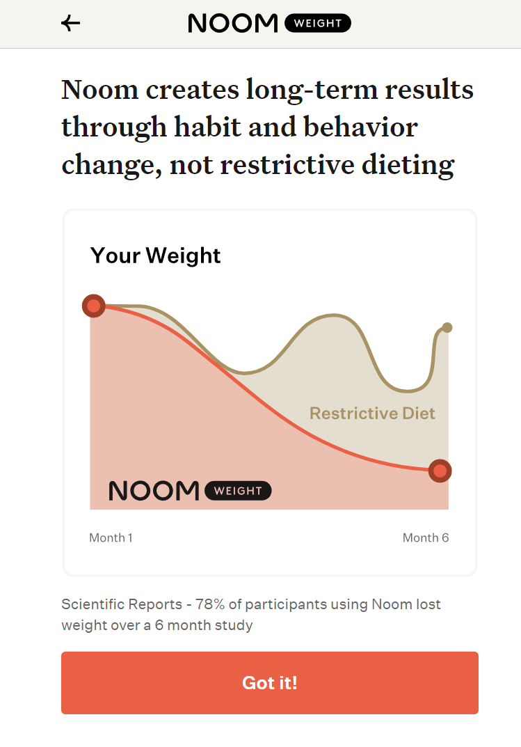

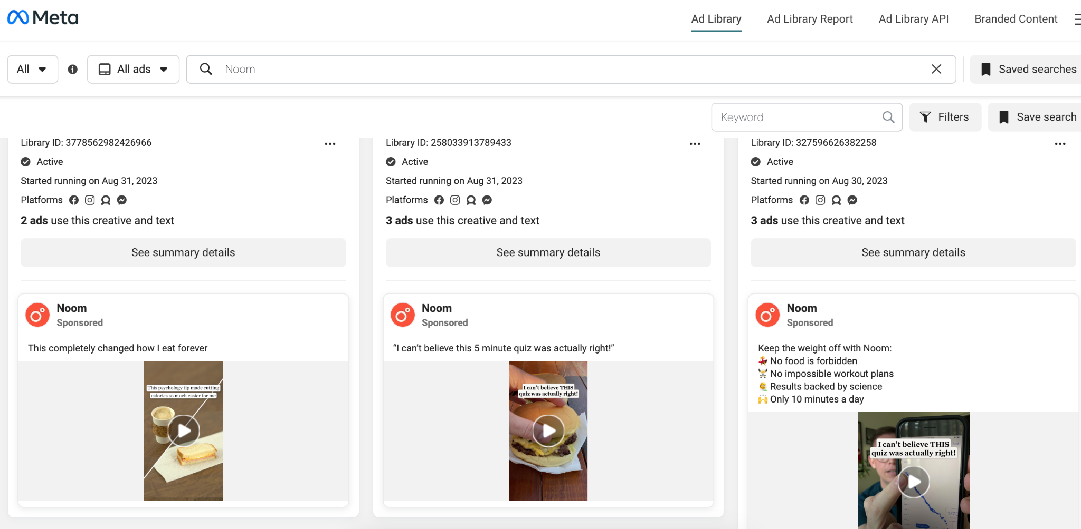

Make the positive questions green and negative red

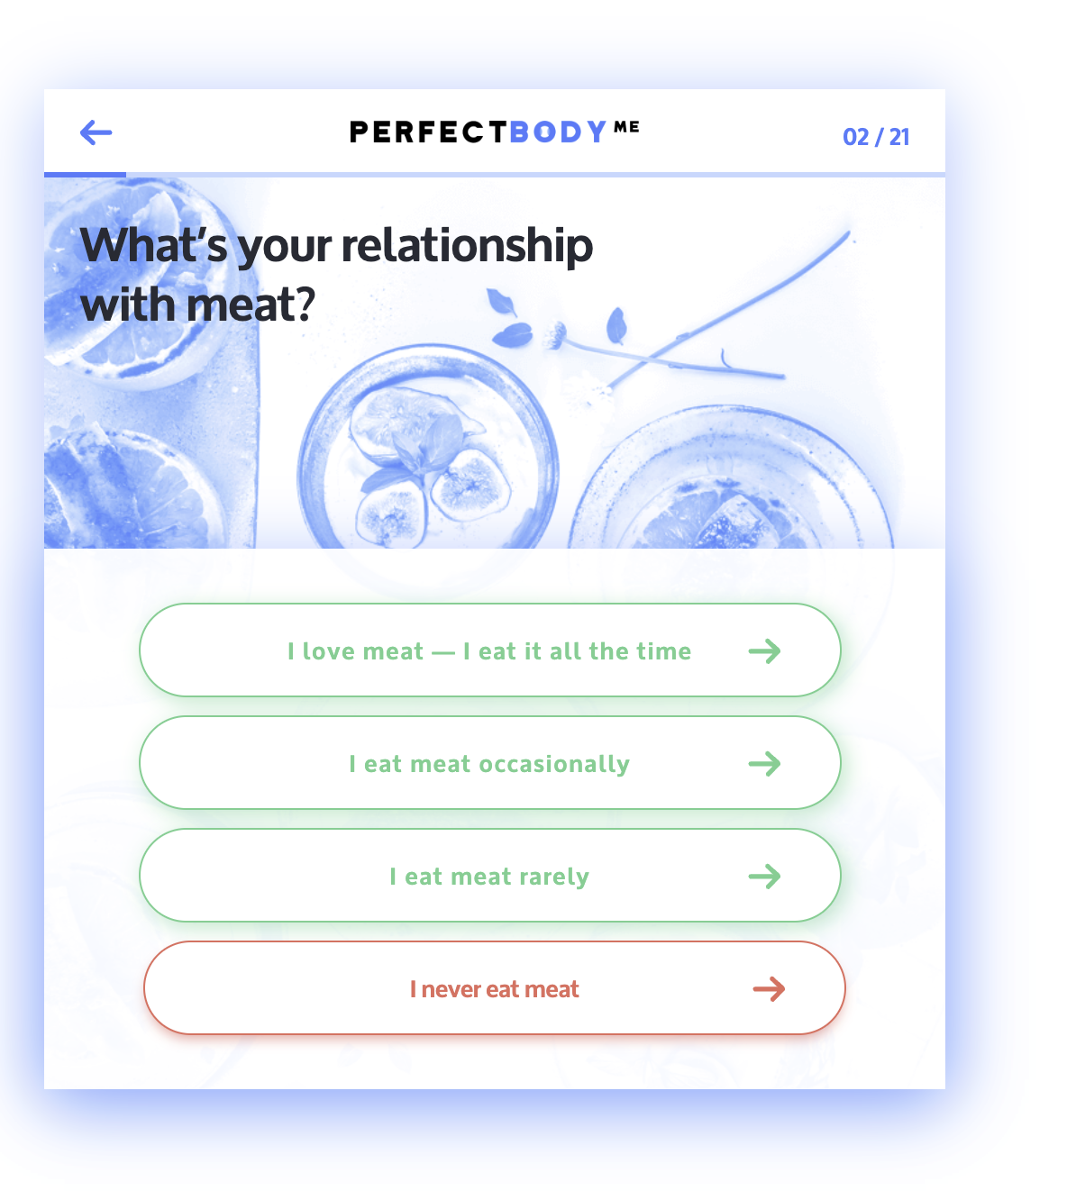

Neutral is orange.

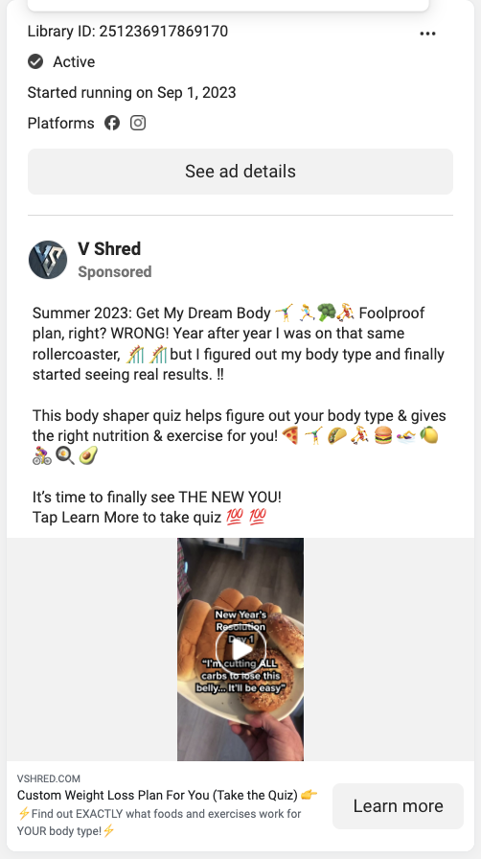

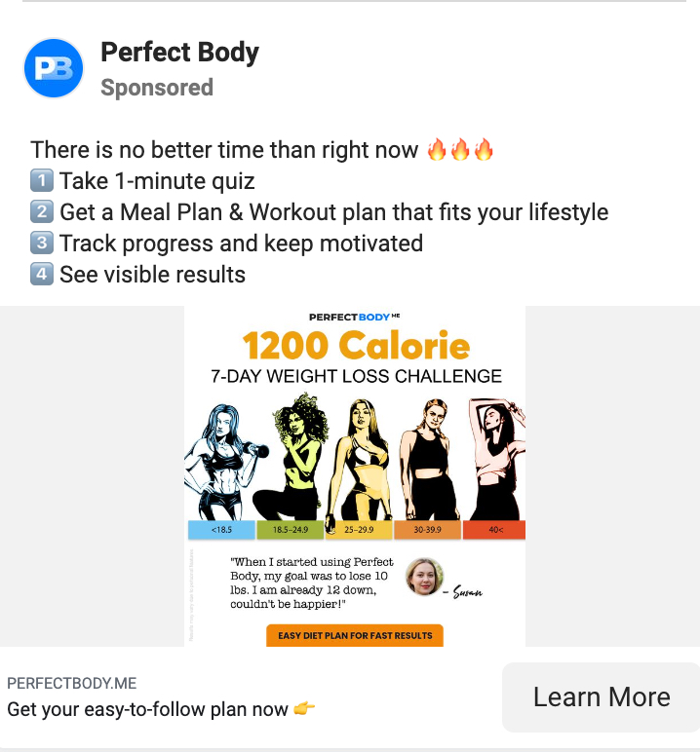

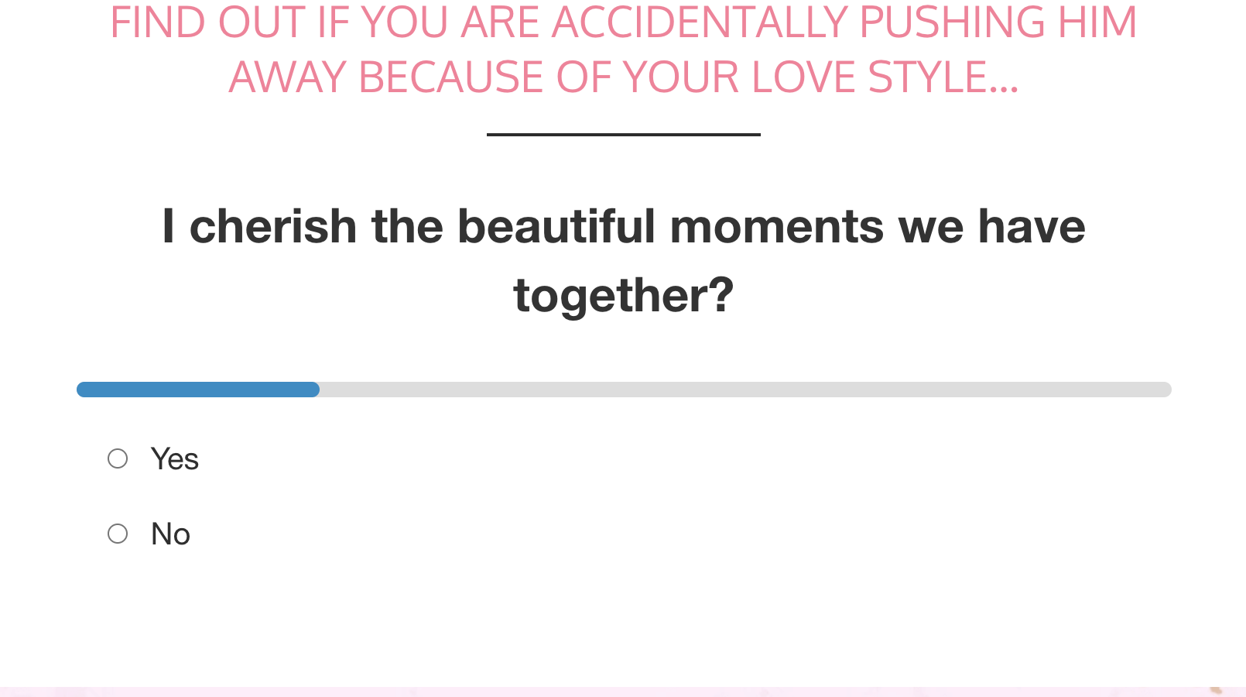

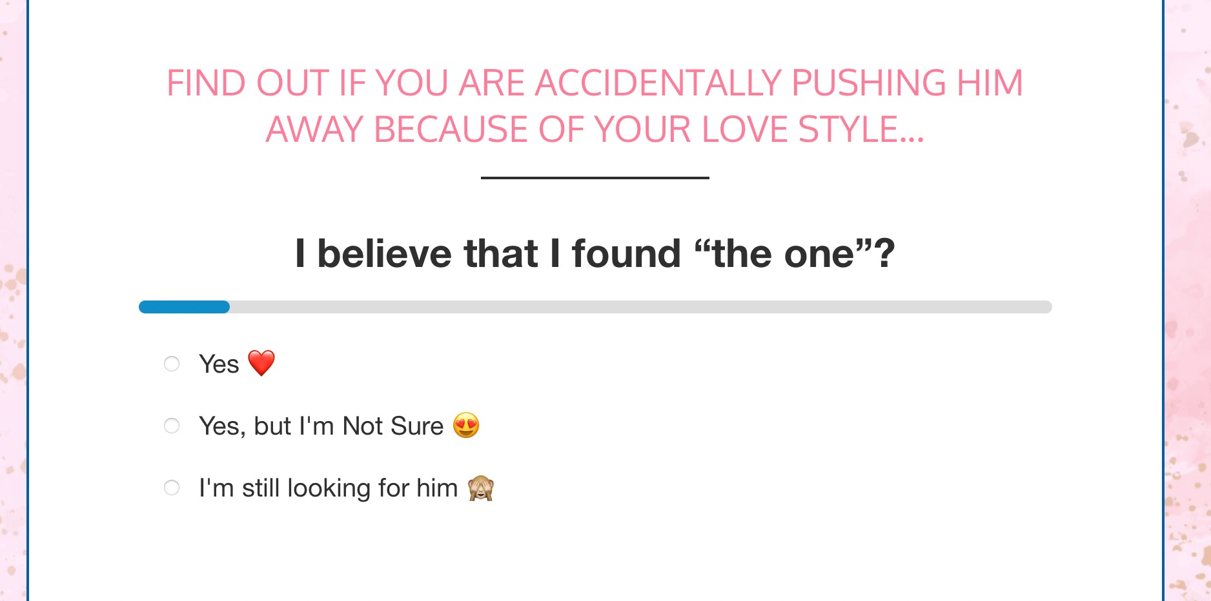

Just a reminder of what you said that when people uncover their limitations, they don't doubt it like when you just point it out - arguing with them rather than against them.
- Isaak Hyde.

Financial question:

How much money do we need to help you make to help you replace your income?

